Module 5

Switch

The Switch tests a certain condition, if the condition is true it performs the  box and if the condition is false it performs the  box.

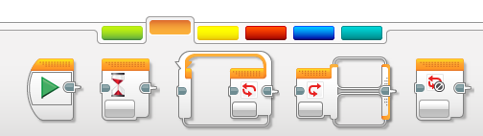

By default it is set to Touch Sensor Mode.

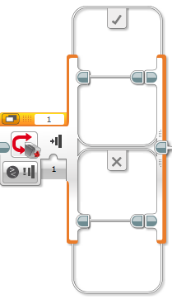

The Mode can be change as shown below.

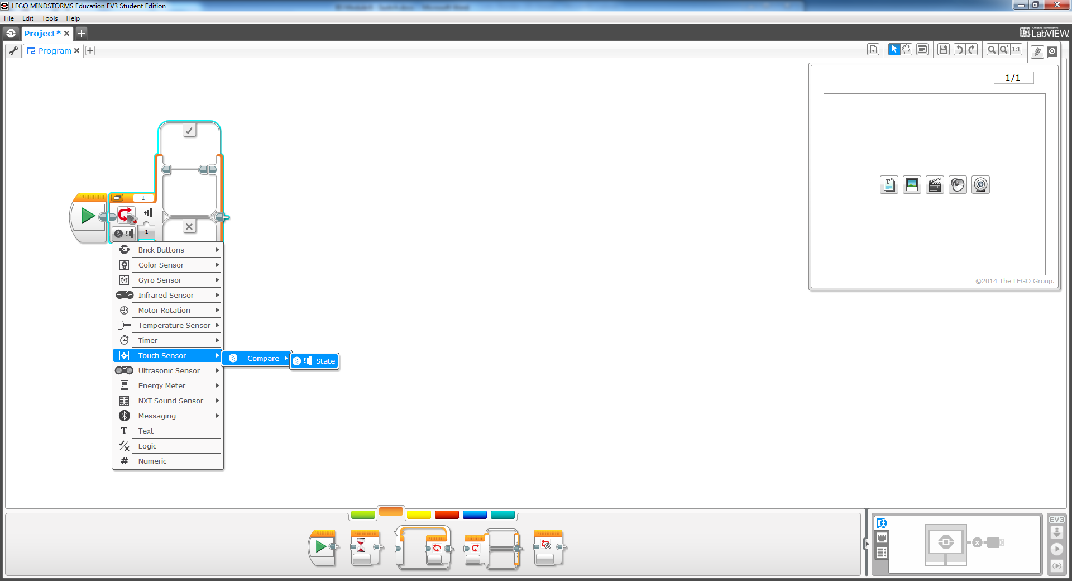

# Activity 1 – Switching Display

## Display

This block allows you to put images and texts on the screen.

Select the white square in the top right corner and pick images from the “LEGO Image Files”.

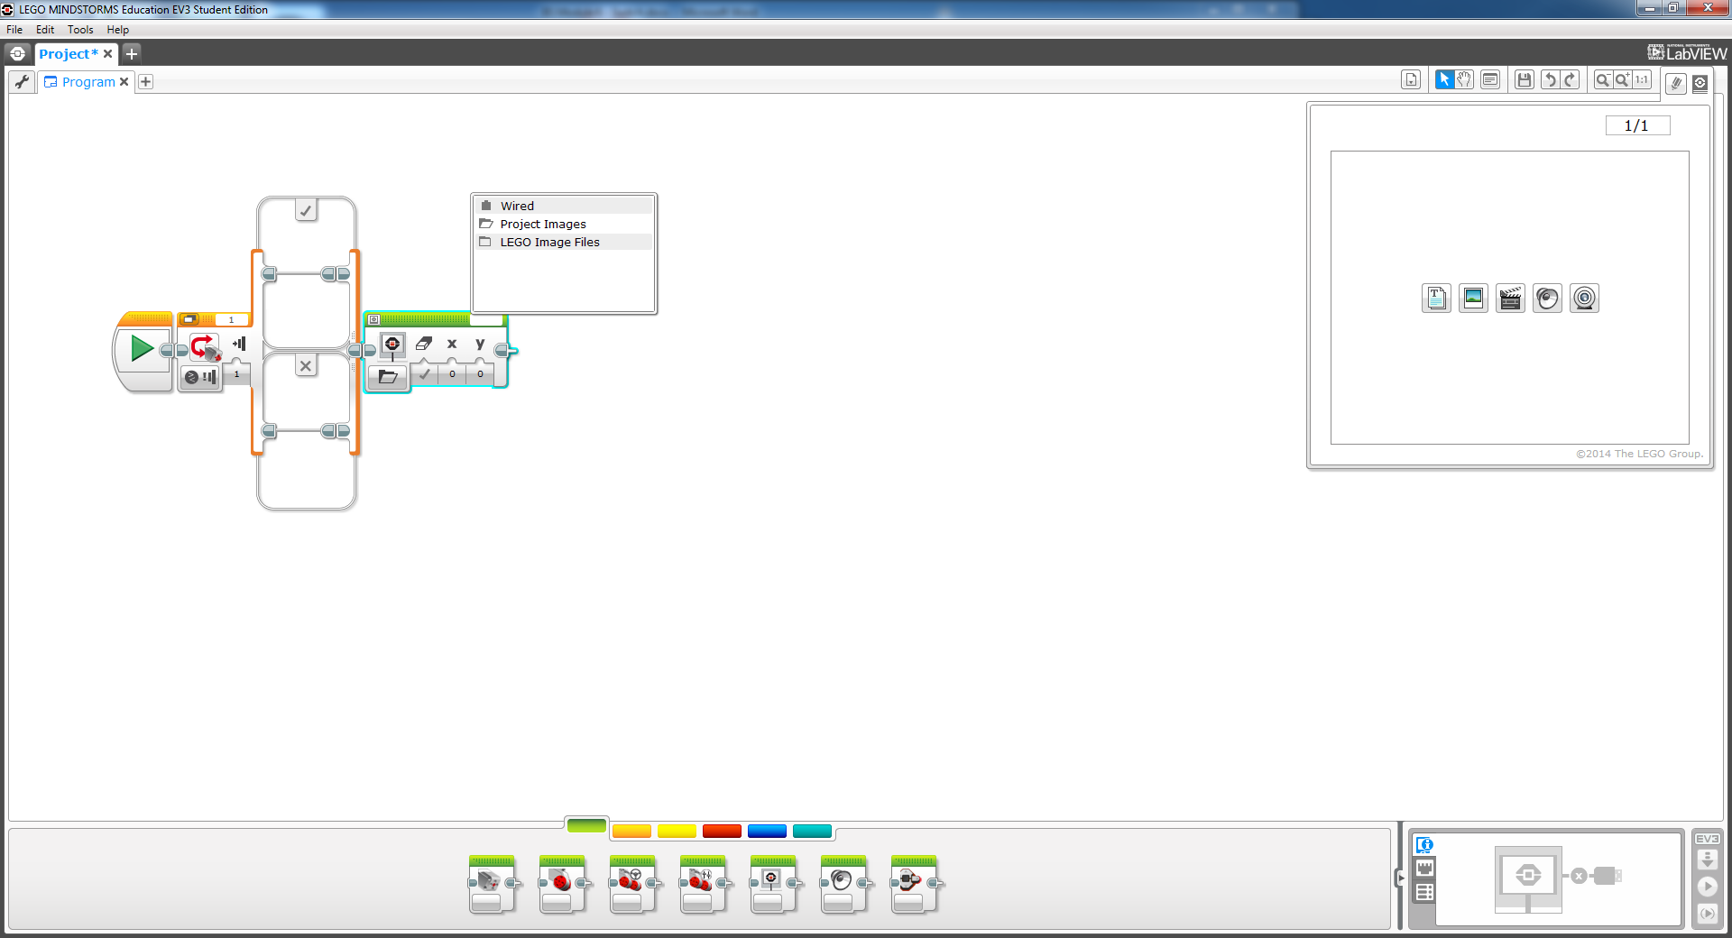

## The Switch

Create a program to change the display on the brick according to the state of a touch sensor.

1. Place a switch in your program with a Display block in each. Select a different image in each Display block.
2. Keep the mode of the switch on Touch Sensor.
3. Choose either state 0 or 1 on the Switch.
4. Put your switch in an Unlimited loop and play your program.

Your images will swap when you press the touch sensor. Try the other states to test them out.

*Hint: when using state 2 put a wait 2 sec block after the display block in the  box.*

# Activity 2

## Tutorial

Open up and complete the tutorial project Robot Educator 🡪 Beyond Basics 🡪 Switch.

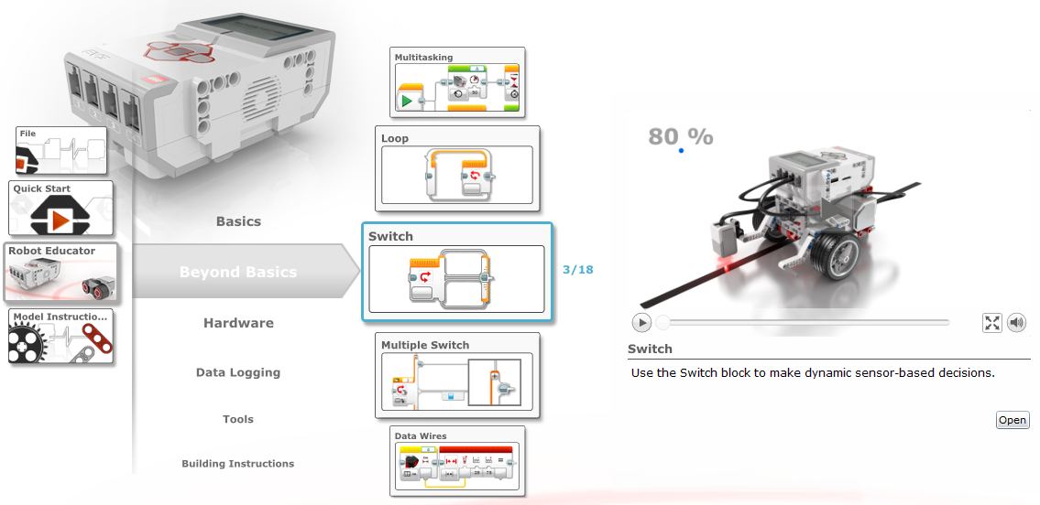

The switch is being used in “Reflected Light Intensity” mode.

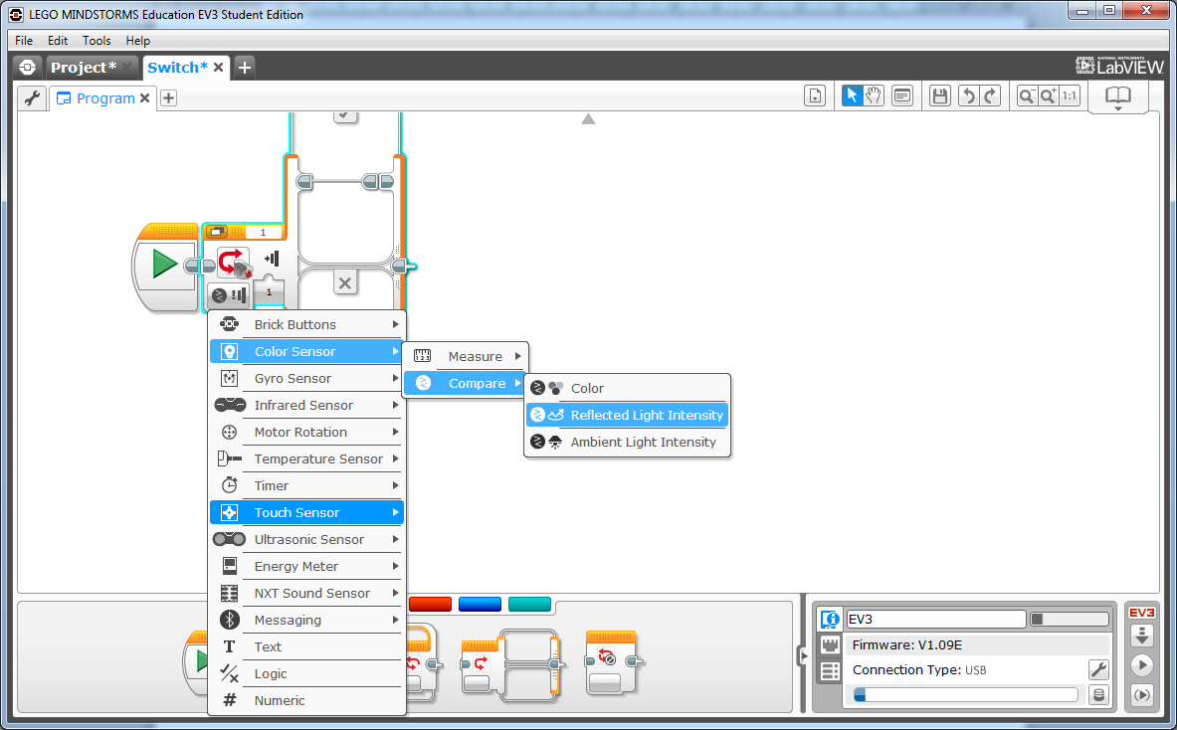

## Challenge

Now that you have had some practice, try this problem.

1. Simplify

Can you simplify the program to only use 1 move block in each switch condition?

*Hint: You might be able to use the Move Steering or Move Tank blocks.*

1. You will notice that your robot is following one side of the line. Can you make it follow the other side of the line?

C:\Users\212547060\AppData\Local\Microsoft\Windows\Temporary Internet Files\Content.IE5\E8RVFMI6\Scissors_icon_black.svg[1].pngThis is a curved line for you to follow. You will want to tape this to a table so it doesn’t move.

C:\Users\212547060\AppData\Local\Microsoft\Windows\Temporary Internet Files\Content.IE5\E8RVFMI6\Scissors_icon_black.svg[1].png